**Make Your Own First Aid Kit**

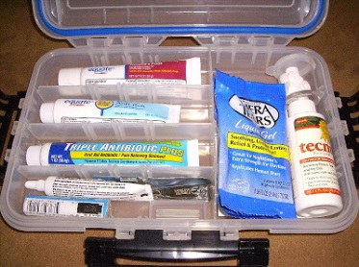

**What to Include:**

For open wounds, cuts, skinned knees, and scratches

* 1 box 12 adhesive compresses
* 3 sizes sterile bandages
* 3 sterile gauze squares
* A small bottle antiseptic

For blisters

* Adhesive compresses or gauze squares
* Narrow adhesive

For sprains

* 1 triangular bandage
* Small scissors

For burns, sunburn

* Tube burn ointment - 5%

For splinters

* Small tweezers
* Needle
* Matches to sterilize

For fainting

* Small bottle aromatic spirits of ammonia

For bites or stings

* Small box bicarbonate of soda

For toothache

* Small bottle oil of cloves

For plant poisoning

* Small bar yellow soap

Ideas for containers to use:

* A cigar box, a tin cracker or candy box - paint and decorate. Put a list of what-to-do inside the lid.
* Make a cloth case with a strap.
* A cloth kit with pockets. Fold over the top, roll up, and tie.